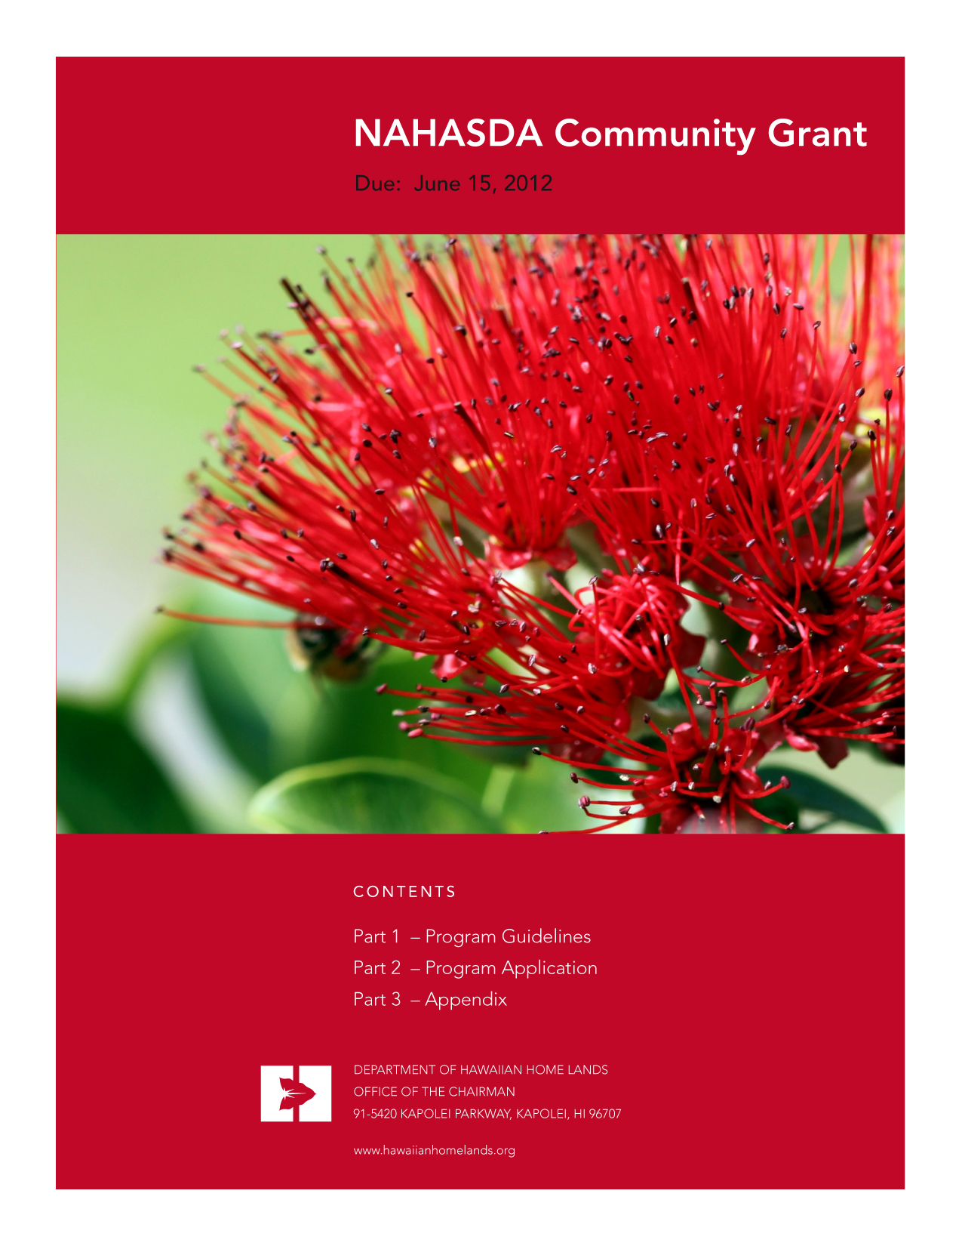
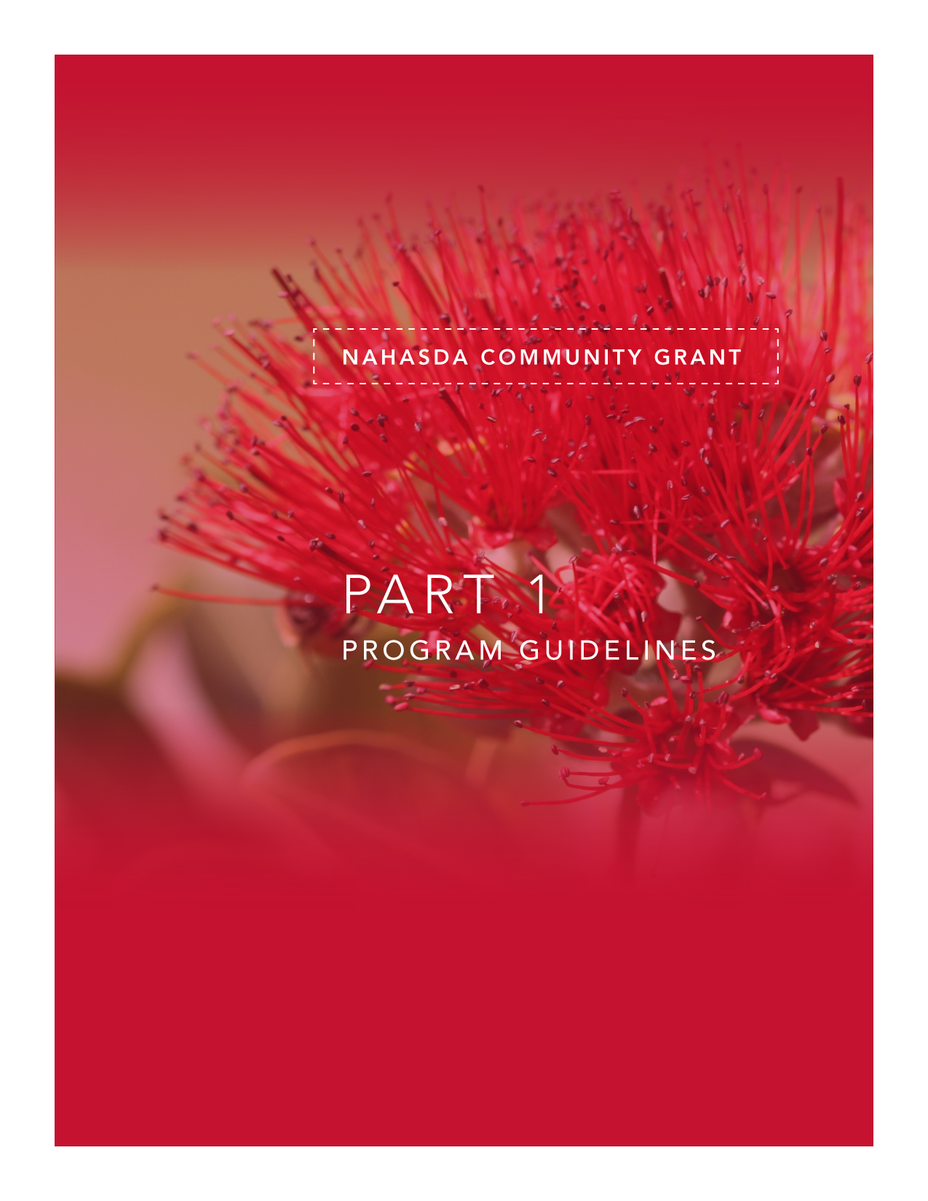

PROGRAM GUIDELINES

TABLE OF CONTENTS
TITLE PAGE

INTRODUCTION 4
NATIVE HAWAIIAN HOUSING PLAN GOALS AND OBJECTIVES 5
ELIGIBLE APPLICANTS 9
ELIGIBLE BENEFICIARIES 9
ELIGIBLE CATEGORIES AND ACTIVITIES 9
FUNDING LEVELS AND PROGRAM/PROJECT TERM 11
PROGRAM/PROJECT CONCEPT AND DEVELOPMENT 11
APPLICATION INSTRUCTIONS 12
APPLICATION DEADLINE 13
APPLICATION SUBMITTAL 13
APPLICATION PROCESS 13
APPLICATION CRITERIA AND SCORING 14
APPLICATION DETERMINATION 16
APPLICATION CYCLE 16
INFORMATION AND ASSISTANCE 16

TO: Native Hawaiian Housing Block Grant (NHHBG) Applicant

FROM: Trisha Paul, Grant Specialist, NAHASDA

SUBJECT: NAHASDA Community Grant Program Guidelines / Application

INTRODUCTION
In 1996, the Congress passed sweeping affordable housing reform legislation for American Indians and Alaska Natives called the Native American Housing Assistance and Self Determination Act (NAHASDA). This legislation, transformed the way that these Native groups provided affordable housing on rural Indian reservations and Alaska Native villages and opened the door for increased partnerships with financial institutions and most importantly, enabled the federal policy of self-determination to be extended to affordable housing. NAHASDA provides the mechanism for Native peoples to receive block grants based on a needs and population based formula and access to a federal mortgage loan guarantee called the Section 184 Guaranteed Loan Program. American Indians and Alaska Natives are empowered through NAHASDA to dedicate these resources based on the individual and unique affordable housing solutions determined by their communities. NAHASDA funding is dedicated to Indian and Alaska Native Tribal Governments for further designation to entities of their choosing to implement affordable housing goals in their communities.

In 2000, the Congress amended NAHASDA by adding Title VIII to provide similar funding for Native Hawaiian families on Hawaiian home lands set aside under the Hawaiian Homes Commission Act of 1920 (HHCA). The Department of Hawaiian Home Lands (DHHL) is the designated recipient for annual Native Hawaiian Housing Block Grants (NHHBG) and loan guarantees. This congressional amendment was the first time in the history of the HHCA that the federal government provided any significant level of financial investment into the Hawaiian home lands program for affordable housing activities.

NAHASDA requires that each block grant recipient develop a five-year plan and a one-year plan for each annual block grant allocation. As such, DHHL prepares, in consultation with the Native Hawaiian community, a Native Hawaiian Housing Plan (NHHP) each year that includes goals, objectives and tasks for implementation by DHHL as recipient and other entities as sub-recipients. NAHASDA further defines the eligible categories and activities by which block grant funding may be expended.
This NAHASDA Community Grant Application is provided to solicit project and program proposals from eligible entities for NAHASDA funding to implement the goals and objectives approved by the Department of Housing and Urban Development (HUD) and described in the NHHP.

2011 NATIVE HAWAIIAN HOUSING PLAN GOALS AND OBJECTIVES
The Department of Housing and Urban Development (HUD) requires DHHL to develop a one (1) year and a five (5) year Native Hawaiian Housing Plan (NHHP) for each appropriation. The following outlines DHHL’s primary goals for this program year for NAHASDA funding to best serve its targeted communities.

Goal No. 1: Increase the affordable housing inventory on Hawaiian home lands to meet the increasing or unmet demand for housing by eligible native Hawaiian households.

Objective 1A: Increase the supply of affordable housing units through on-site and off-site development, to include but not limited to infrastructure, streets, utilities, and engineering, for single-family housing.

Tasks and Activities: Provide funding for on-site or off-site development improvements for at least one single-family residential subdivision on the island of O'ahu to serve at least 20 eligible native Hawaiian households and one on an outer island to serve at least 10 eligible native Hawaiian households.

Objective 1B: Increase the supply of affordable housing units through self-help (sweat equity) projects.

Tasks and Activities: Provide funding for technical assistance for at least one affordable housing project that utilizes the self-help construction method to assist at least 20 eligible native Hawaiian households achieve homeownership.

Objective 1C: Reduce the price of housing by providing direct assistance to eligible native Hawaiian homebuyers through downpayment assistance and/or principal reduction subsidies, low/no interest rate loans, matching funds for Individual Development Accounts (IDAs), or other means/methods that become available.

Tasks and Activities:
  - Provide funding for subsidies, such as downpayment assistance/principal reduction or matching funds for Individual Development Accounts, which may be recaptured during the useful life period, for at least 10 eligible native Hawaiian households.

  - Provide low-interest or no-interest loans to at least 20 eligible native Hawaiian households.

Objective 1D: Increase the supply of affordable housing units by providing funding for house construction for single-family housing which may include solar water heating, photovoltaic panels, and/or other energy efficient features.

Tasks and Activities: Provide funding for at least one single-family residential subdivision on the island of O'ahu to serve at 20 eligible families and one single family residential subdivision on the neighbor islands to serve 10 families.

Objective 1E: Assess the demand for alternative housing options on Hawaiian Home Lands and implement programs as applicable.

Tasks and Activities:
- Complete a data assessment/analysis of the demand for rental housing on HHL by current DHHL applicants.

- Explore the feasibility of implementing a rental program for DHHL applicants on HHL given the Hawaiian Homes Commission Act requirements vs. the feasibility of assisting partners in developing rental properties on HHL.

- As applicable, establish Administrative Rules and Operational Policies should it be deemed feasible and necessary to implement a rental program for DHHL applicants on HHL.

Objective 1F: Increase the supply of affordable housing inventory by subdividing lots or relocating homes, as practicable.

Tasks and Activities: .
- Subdivide lots returned to DHHL’s inventory, as practicable, and re-award to eligible native Hawaiian households.

- Relocate existing homes on lots returned to DHHL to facilitate subdivision of said lot, as practicable.

Objective 1G: Increase the supply of affordable housing units through acquisition of land and/or housing units to be included in DHHL’s inventory of affordable housing for eligible native Hawaiian families.

Objective 1H: Capitalize a revolving loan fund that will provide financing to assist native Hawaiian NAHASDA eligible families with affordable mortgage financing options to achieve and sustain homeownership on Hawaiian Home Lands.

Goal No. 2: Reduce the number of homes, occupied by eligible native Hawaiian households, that are in need of repair or replacement to relieve substandard living conditions, that are in need of renovation to relieve overcrowding, or to provide energy efficient renovation/upgrades.

Objective: Increase the number of programs and/or partnerships that provide assistance to eligible native Hawaiian households in the repair or replacement or their homes or to renovate their homes as a means to relieve over crowding, or to provide energy efficient renovations/upgrades.

Tasks and Activities:
- Provide low-interest or no-interest loans and/or grants to at least 10 eligible native Hawaiian households to repair/rehabilitate existing housing units to address substandard living conditions, to renovate existing housing units to address over crowding, or to provide energy efficient renovations/upgrades..

- Initiate new partnerships and/or encourage the development of programs that target areas or needs that are not currently being served by existing City and County, or other, partnerships/programs.

Goal No. 3: Increase alternative energy resources and/or programs that will benefit eligible native Hawaiian households.

Objective 3A: Provide funding to eligible entities to implement alternative energy resource programs for eligible native Hawaiian households as a means to reduce housing costs and in alignment with the DHHL energy policy.

Tasks and Activities:
Provide funds, to include direct loans and/or grants to eligible beneficiaries, and/or implement a program, to install energy efficient devices to include, solar water heating, photovoltaic panels, and/or other energy efficient features for eligible native Hawaiian households.

Goal No. 4: Increase community access to NHHBG resources to address public safety needs, organizational needs, community policing needs, or eligible “model” activity needs.

Objective: Support communities on Hawaiian Home Lands to assess the viability of developing and implementing eligible NHHBG programs and activities that will benefit their communities such as, but not limited to, safety enhancements, organizational support, community policing, or eligible “model” activities.

Tasks and Activities:
- Provide resources for homestead communities to determine the number/percentage of their residents that are NHHBG eligible (at or below 80% AMI).

- Assist homestead communities in addressing community safety needs, as warranted by the particular community, and in alignment with allowable activities for the NHHBG.
- Assist homestead communities with community policing activities, as warranted by the particular community, and in alignment with allowable activities for the NHHBG.

- Promote partnerships with existing providers and the police departments within each county to address public safety needs.

- Assist homestead communities and affiliated organizations by working in coordination with the community/organization and HUD in determining what types of “model activities” DHHL may consider for NHHBG funding that include elements such as social, educational, cultural, recreational, or medical related activities for a more holistic approach to housing than just providing shelter.
.
Goal No. 5: Increase access to educational or training programs that assist native Hawaiian families.

Objective 5A: Develop, maintain, or improve educational and/or training programs to address financial, home repair, home maintenance, or other needs for eligible native Hawaiian households.

Tasks and Activities:
- Continue to work with and/or fund eligible entities, including DHHL’s Home Ownership Assistance Program (HOAP), to provide financial literacy education and counseling, home buyer education, and foreclosure prevention to eligible native Hawaiian households.

- Continue to work with and/or fund eligible entities to provide home maintenance and/or self-help home repair training programs to eligible native Hawaiian households.

- Provide support or funding for other eligible educational or training programs to eligible native Hawaiian households.

Goal No. 6: Increase administrative capacity of DHHL to implement and monitor NHHBG programs.

Objective 6A: Comply with both state and federal requirements in the administration of the NHHBG and ensure adequate organizational capabilities to manage the various NHHBG programs, properties, and assets on Hawaiian home lands.

Tasks and Activities:
- Ensure that NHHBG programs are adequately staffed.

- Work with ONAP staff to ensure appropriate training for DHHL staff and sub-recipients for the administration of NHHBG programs.

Objective 6B: Establish collaborative partnerships to address affordable housing needs.

Tasks and Activities:
- Conduct community outreach and education, as needed, to address community interest in NAHASDA, the NHHP, and the DHHL’s NAHASDA Community Grant Program.

- Engage local lenders to utilize the 184A guaranteed loan as another lending product.

Proposals must address the goals and activities/tasks identified in the 2011 NHHP. You may refer to the DHHL website “http://hawaii.gov/dhhl/nahasda/publications/publications” to view the entire 2011 NHHP.

ELIGIBLE APPLICANTS
An applicant must be a local public entity, nonprofit corporation or a for-profit corporation engaged in or that will be engaged in developing, conducting, administering or coordinating assistance programs which will aid eligible beneficiaries.

ELIGIBLE BENEFICIARIES
All funded program/projects must serve eligible beneficiaries. Eligible beneficiaries are low-income Native Hawaiian families who are eligible to reside on the Hawaiian home lands.

Low-income Native Hawaiian families are those, whose total household income does not exceed 80% of the HUD median income for the area. (State of Hawaii income guideline can be found in Page 18 of the Appendix).

Native Hawaiian means any individual who is:
- A citizen of the United States; and
- A descendant of the aboriginal people who, prior to 1778 occupied and exercised sovereignty in the area that currently constitutes the State of Hawaii, as evidenced by;
  - Genealogical records;
  - Verification by kupuna (elders) or kama’aina (long-term community residents); or
  - Birth records of the State of Hawaii

ELIGIBLE CATEGORIES AND ACTIVITIES
Eligible affordable housing categories are 1) development, 2) housing services, 3) housing management services, 4) crime prevention and safety activities and 5) model activities. NAHASDA funds may only be used for eligible categories/activities that are consistent with DHHL’s 2011 Native Hawaiian Housing Plan.

Category 1 - Development - All development must occur on Hawaiian home lands.
(a) NAHASDA funds may be used for the acquisition, new construction, reconstruction, or moderate or substantial rehabilitation of affordable housing for homeownership or rental, which may include:
- Real property acquisition;
- Acquisition of affordable housing;
- Financing acquisition of affordable housing by homebuyers through:
  - Down payment assistance
  - Closing cost assistance
  - Direct lending; and
  - Interest subsidies or other financial assistance
- New construction of affordable housing;
- Reconstruction of affordable housing;
- Moderate rehabilitation of affordable housing, including but not limited to:
  - Lead-based paint hazards elimination or reduction;
  - Improvements to provide physical accessibility for disabled persons; and
  - Energy-related improvements;
- Substantial rehabilitation of affordable housing, including but not limited to:
  - Lead-based paint hazards elimination or reduction;
  - Improvements to provide physical accessibility for disabled persons; and
  - Energy related improvements
- Site improvement, including recreational areas and playgrounds for use by residents of
affordable housing and on-site streets and sidewalks in housing areas already assisted with the Native Hawaiian Housing Block Grant (NHHBG);
- The development of utilities and utility services;
- (10) Conversion
- (11) Demolition
- (12) Administration and planning; and
- Other related activities, such as environmental review and architectural and engineering
plans for the affordable housing project.
(b) Multi-unit projects. Funds may be used to assist one or more housing units in a multi-unit project. Only the actual NAHASDA eligible development costs of the assisted units may be charged to the NAHASDA Program. If the assisted and unassisted units are not comparable in terms of size, features, and cost of bedrooms, the actual cost of the NAHASDA-assisted units can be determined by prorating the total NAHASDA eligible development costs of the project so that the proportion of the total development costs charged to the NAHASDA Programs does not exceed the proportion of the NAHASDA-assisted units in the project.

Category 2 - Housing Services
Funds may be used for the provision of housing-related services for affordable housing, including:

(a) Housing counseling in connection with rental or homeownership assistance;
(b) The establishment and support of resident organizations and resident management corporations;
(c) Energy auditing;
(d) Activities related to the provisions of self-sufficiency and other services;
(e) Homelessness prevention activities;
(f) Payments to prevent foreclosure on a home; and
- Other services related to assisting owners, tenants, contractors, and other entities participating or seeking to participate in other housing activities assisted pursuant to the Act and this part.

Category 3 - Housing Management Services
Funds may be used for the provision of management services for affordable housing, including:
(a) The preparation of work specifications;
(b) Loan processing;
(c) Inspections;
(d) Tenant selection;
(e) Management of tenant-based rental assistance; and
(f) Management of affordable housing projects.

Category 4 - Crime Prevention and Safety Activities
Funds may be used for the provision of safety, security, and law enforcement measures and activities appropriate to protect residents of affordable housing from crime, including the costs of:
(a) Physical improvements for affordable housing to enhance security, such as, fences, monitors, locks, and additional lighting;
(b) Security personnel for affordable housing; and
(c) Equipment for patrols

Category 5 - Model Activities
Funds may be used for housing activities under model programs that are:
(a) Designed to carry out the purposes of the Act and this part; and
(b) Specifically approved by HUD as appropriate for those purposes (HUD approval is required prior to Notice to Proceed).

The project you propose must address the Goals and Objectives outlined in the 2011 NHHP. Even if a project is an eligible activity listed above, it will NOT be considered if it is not identified in the 2011 Native Hawaiian Housing Plan.

FUNDING LEVELS AND PROGRAM/PROJECT TERM
The minimum funding level of this program is $10,000

There is currently no maximum funding level.

The program/project term should be estimated at 12 months from date of Notice To Proceed, no-cost extensions may be granted to attain goals as applicable.

PROGRAM/PROJECT CONCEPT AND DEVELOPMENT
The NAHASDA Community Grant Application requires that you describe in great detail the particular program/project you are proposing and requesting to be funded. The development of the proposed program/project follows a specific process and outline. This process relates directly to the questions you will be asked to answer in the application.

What follows is a brief explanation of the program/project development process to help you to better understand the application.

- The initial step involves identifying and describing the specific Targeted Community to be served. This includes explaining the issues and challenges of that community and stating which of those needs the proposed program/project will address.

- To explain the program/project you are proposing, you will need to clearly state the primary Goal of the program/project. The program/project goal is a general statement that represents the desired outcome. The program/project goal should obviously be linked to the community needs of the targeted community that this particular program/project intends to focus on.

- The next step is to determine the series of Objectives that need to be accomplished in order to achieve the stated program/project goal. An objective is a concise statement of one thing that must be completed to help accomplish your program/project goal. The objectives collectively describe HOW the program/project goal will be fulfilled.

- For each objective you will need to complete a Work Plan. The work plan describes in detail the planned approach for reaching the objective by listing the various Activities to actualize the objective, the Outcome that states the expected benefits or results from achieving the objective, Who will be responsible and Timeframes. You will also need to explain the Criteria or measurable ways you will Evaluate whether the objective produced the expected outcome (benefits/results) that you indicted. When contracting activities (those outsourced by your agency/organization to a 3rd party for completion) you must adhere to Federal Procurement Guidelines. This work should be indentified as work to be “subcontracted” in your proposal and reflected in your budget.

- Additionally, you will also need to explain how your organization and your community partners have the experience, capabilities and resources to make the program/project successful and achieve the stated program/project goal.

Although the application structure does not follow the exact order outlined above, you will find all the components included in the application and you will need to respond to each one. At times, you will also need to support your ideas and plans with documentation. You will submit this supporting documentation as attachments with your application as directed throughout the application.

Samples of key portions of the application and visual representations of this process can be found for your reference in the Application Appendix.

APPLICATION INSTRUCTIONS
The attached application is the standard application for all NAHASDA Community Grant applicants. The application must be filled out completely and include all requested information. Please respond to all application guidelines by checking answer boxes where required, furnishing requested information and giving complete narrative answers where appropriate. If necessary, insert additional pages into the Appendix in order to provide complete information. Be aware that the review committee will only have knowledge that you provide in the application so be complete and concise.

Include all attachments. Indicate “not applicable” on both the application and in the attachment, where appropriate. If information is not available but is necessary to determine the eligibility of the applicant and/or the eligibility of the program/project (see Eligibility Criteria and Completeness Review section above), DHHL staff may reject the application as incomplete.

A checklist is furnished in the Application Appendix. Be sure all attachments are complete and included with the application. In addition to the checklist of attachments, the Appendix of the application has a set of tools to assist the applicants in the presentation of required information.

APPLICATION DEADLINE
June 15, 2012

APPLICATION SUBMITTAL
The application must be assembled as follows:

- Submit the application and attachments in a three-ring binder.
- Place a cover sheet on the front of the binder with the name of the organization submitting the application, the name of the program/project, and the date submitted.
- Place the completed application behind the first tab and label the tab “Application.”
- Using tabbed dividers separate the attachments by the application Section Letter and Item Number, i.e. Section A 3.2.
- All attachments must be ordered according to the checklist in the Application Appendix.

The package must include one original, complete DHHL application, with attachments.

Mail the package to:
Department of Hawaiian Home Lands
Attn: NAHASDA
P.O. Box 1879
Honolulu, HI 96805

No facsimiles or electronic submissions will be accepted.

APPLICATION PROCESS
Staff will conduct an eligibility and completeness review. An application deemed to be incomplete or ineligible will be removed from further review. The applicant will be notified in writing of the Department’s determination. The eligibility and completeness review will be based on the minimum threshold criteria set forth below:

- Application completeness: Applications must be filled out completely and include all attachments. A certified board resolution naming the individual authorized to submit the application and enter into a contract with DHHL, should the proposal be awarded, must be included and have the appropriate original signatures. The application must bear the original signature of the person named in the resolution.

- Applicant eligibility: An applicant must be a local public entity, nonprofit corporation or a for-profit corporation engaged in or that will be engaged in developing, conducting, administering or coordinating assistance programs which will aid eligible Native Hawaiians.

3. Applicant eligibility is required to include a Certificate of Vendor Compliance with your application. As of July 1, 2011 State and County procurement personnel are required to utilize the Hawaii Compliance Express (HCE) to obtain proof of compliance prior to award. The link to HCE is attached for your convenience. https://vendors.ehawaii.gov/hce/splash/welcome.html Organizations who need to register in HCE should follow instructions of FAQ No. 3, “How do I register my business in the HCE?” located at the website. You will need the following items for your registration online; Federal and State ID numbers, and a credit card for the registration fee to register on the site. The annual registration fee is $12.00. Activation of your organization's information on the HCE site will take approximately 5-10 days from registration date.

4. Project Proposal eligibility: Applications will be reviewed, scored and selected separately with two types of review.
  - A threshold review to determine applications’ eligibility
  - A technical review to rate the application based on the rating factors.

5. Each proposal will be reviewed and scored. DHHL may not fund all project proposals submitted or may only award partial funding, as applicable.

APPLICATION CRITERIA AND SCORING
All applications that are eligible and complete will be scored according to the following criteria:

- Program/Project Objectives and Work Plan: (30 pts.) This factor addresses the quality and cost-effectiveness of your proposed work plan, the commitment of your organization to the proposed activities, and your intended objectives and how they would help DHHL to accomplish the goals and objectives set forth in the NHHP and the overall program’s/project’s impact on the targeted community.

- Prior Experience: (20 pts.) This factor addresses the extent to which your organization has successfully implemented similar programs in the past. Articulate prior successes, challenges or struggles, and solutions to the challenges or struggles you’ve identified.

- Current Capacity: (20 pts.) This factor addresses your organizational ability to complete your proposed project successfully and in a timely manner. Articulate expertise of staff and/or any competitive advantages your organization may have with regard to the program/project you are proposing. Highlight the capacity of your organization to complete the Objectives set forth in your Work Plan.

- Community Needs/Extent of Problem: (10 pts.) This factor addresses the extent to which there is a need for funding your proposed program activities, your indication of urgency to meet this need in your community (supported with appropriate data/sources specific to the community need and the proposed activity), and your organizations ability to adequately address this need through the program/project you are proposing.

- Partners and Resources: (10 pts.) This factor addresses the ability of the applicant to secure resources that can combine with NHHBG program funds to achieve program objectives.
  - DHHL will consider the extent to which you have in-kind contributions and have partnered with other entities to secure additional resources.
  - Letters of specific commitment that are dated no earlier than one month prior to the date of this application are required.

- Coordination, Self-Sufficiency, and Sustainability: (10 pts.) This factor addresses the extent your organization coordinates activities with other organizations, participates in your community’s planning process, and is working towards addressing a need in a holistic and comprehensive manner through linkages with other activities in the community to include:
  - Specific coordination activities related to the application prior to submission.
  - How your organization participates in the community’s planning process. Include how you will take steps to develop linkages to coordinate comprehensive solutions to the problems/needs identified.
  - Institutionalization of the program’s/project’s activities and how the proposed program/project results will be sustained.

Each scoring criteria has been assigned a possible point value. The possible point value represents the greatest number of points that your application can receive for a given criteria. The following table outlines the criteria and the possible point value assigned to each.

CRITERIA | POINTS POSSIBLE
- Program/Project Objectives and Work Plan | 30 points
- Prior Experience | 20 points
- Current Capacity | 20 points
- Community Needs/Extent of Problem | 10 points
- Partners and Resources | 10 points
- Coordination, Self-Sufficiency and Sustainability | 10 points
TOTAL POINTS AVAILABLE: | 100 points

APPLICATION DETERMINATION
Submitted applications will be reviewed by DHHL staff for completeness and will receive a response within approximately 30 days from the closing deadline. The applicant will receive a notice with one of the following determinations:

- Accepted
- Deferred for additional information
- Denied with comment

In the event that DHHL has deferred the application for additional information, the notice will outline the information needed to complete the review of the application and the timeframe in which it is to be submitted. Untimely submittal of requested information may result in the rejection of the application. All complete applications will be reviewed by an evaluation committee.

APPLICATION CYCLE
Applications are available for the NAHASDA Community Grant Program year-round to allow applicants the time to develop the grant or funding application; however, applications will only be accepted for consideration 30 days prior to due date. The following chart outlines the approximate dates of the application cycle:

Due Date | Review Period | Award Notification Period
06/15/12 | 06/30/12 to 08/31/2012 | September 2012

INFORMATION AND ASSISTANCE
It is strongly recommended that care and prudence be exercised in the planning of proposed program/projects, selection of development team members and in the preparation of this application and the attachments. An application that is deemed incomplete based on the above stated eligibility criteria shall be rejected. Staff is available to answer questions regarding the program or the completion of the application and attachments. Please call DHHL at (808) 620-9285. Thank you for your interest in DHHL’s NAHASDA Community Grant Program.
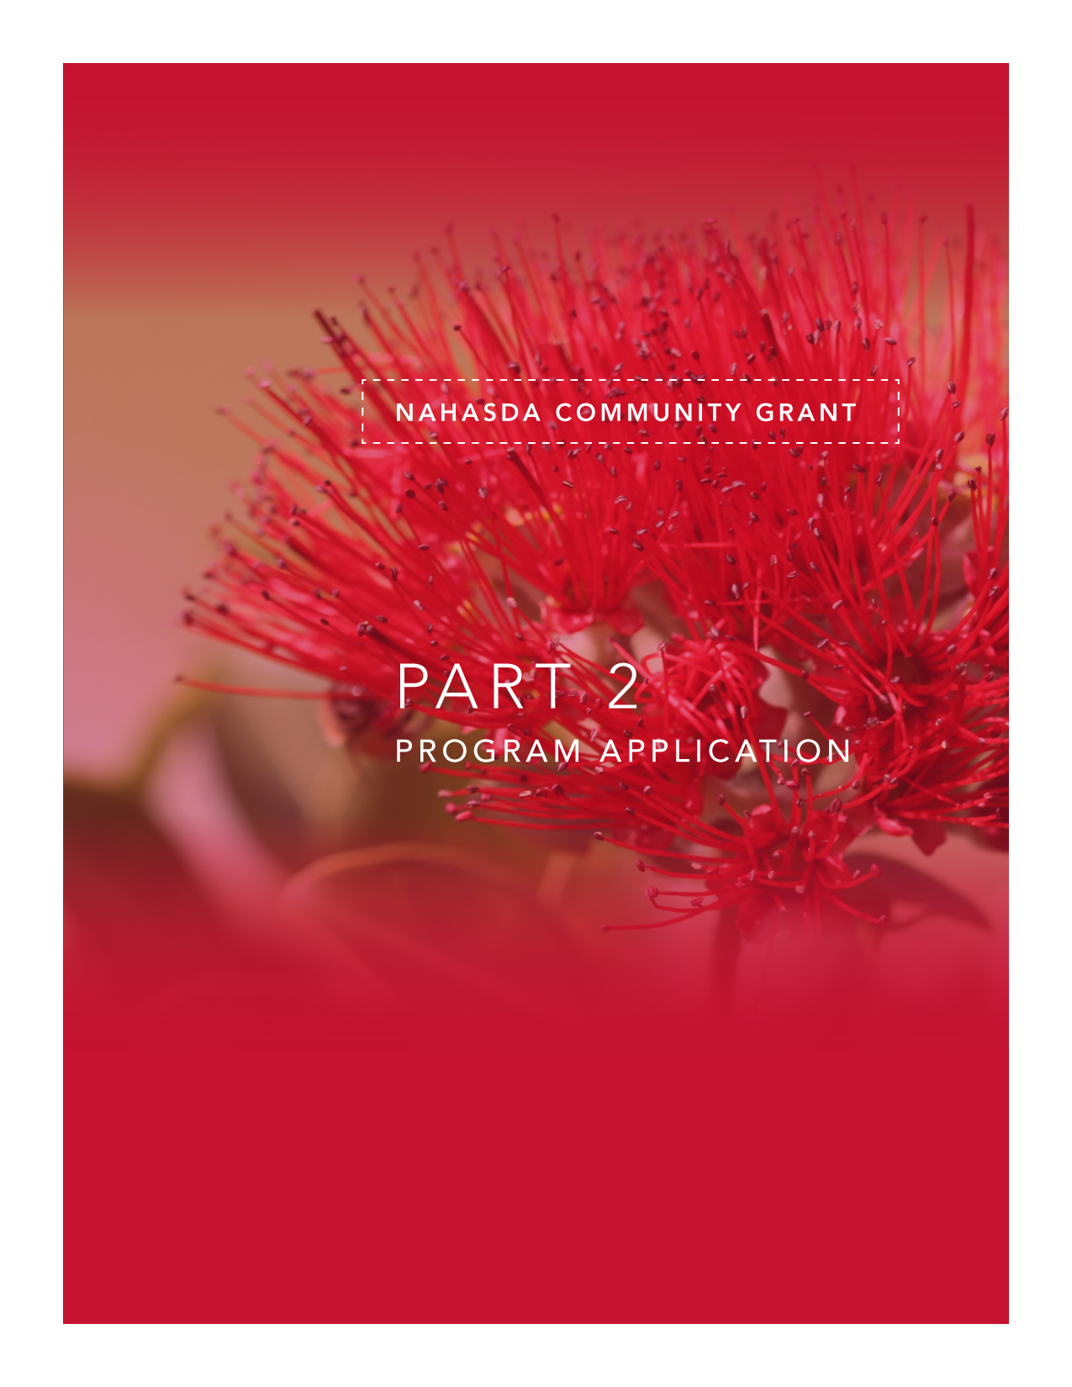

PROGRAM APPLICATION

TABLE OF CONTENTS
TITLE PAGE
SECTION A. 1
1. APPLICANT INFORMATION 1
2. FUNDING REQUEST 1
3. APPLICANT BACKGROUND AND PRIOR EXPERIENCE (20 pts.) 2
4. LEGISLATIVE DISTRICT & REPRESENTATIVE OF THE PROJECT LOCATION 4

SECTION B. 5
1. PROPOSED PROGRAM/PROJECT including CURRENT CAPACITY (20 pts.) 5
2. TARGETED COMMUNITY NEEDS/EXTENT OF PROBLEM(10 pts.) 6
3. PROGRAM/PROJECT OBJECTIVES AND WORK PLAN (30 pts.) 7
4. PARTNERS AND RESOURCES (10 pts.) 10
5. COORDINATION, SELF-SUFFICIENCY/SUSTAINABLITY (10 pts.) 11
6. PROGRAM/PROJECT BUDGET 12
7. PROGRAM/PROJECT ADMINISTRATION 14

SECTION C. 15
1. DHHL NATIVE HAWAIIAN HOUSING PLAN GOALS AND OBJECTIVES 15
2. NAHASDA ELIGIBLE CATEGORIES AND ACTIVITIES 16

SECTION D. 17
1. CERTIFICATIONS 17
2. DHHL CERTIFICATIONS 20
3. APPLICATION AUTHORIZATION 21

NAHASDA FUNDING APPLICATION  Submit a copy of the application with the required attachments to:  DEPARTMENT OF HAWAIIAN HOME LANDS  P.O. Box 1879  Honolulu, HI 96805 | FOR OFFICE USE ONLY: | GRANT NUMBER:
 | Date Received: | CONTRACT NUMBER :
 | Initial Request | Date Reviewed:
 | Resubmission | Budget Information
 | Renewal | Grant/Contract Awarded: $
 | Approved | Cost Share Awarded: $
 | Disapproved | Matching Funds Awarded: $

SECTION A.

APPLICANT INFORMATION

Organization Name:
Mailing Address:
City, State, Zip Code:
Physical Address:
City, State, Zip Code:
Contact:
Title:
Phone: Fax:
E-mail Address:
Website:

FUNDING REQUEST

Please check which type of fund(s) you are applying for and complete the information below:

 | LOAN | GRANT
Total amount of NAHASDA funds requested: | $ | $
Amount from other sources:
Matching | + $ | + $
Cost Sharing | + $ | + $
Value of In-Kind Services | + $ | + $
Total Cost of Program/Project | = $ | = $

APPLICANT BACKGROUND AND EXPERIENCE

  - TYPE OF ORGANIZATION: Please check and complete the appropriate items:
Public Body
Nonprofit Corporation with 501(c)(3)
Nonprofit Corporation without 501(c)(3)
Using fiscal sponsor w/501(c)(3)
Private
Date of Incorporation
FEIN ____________________________________

  - ORGANIZATION LEGAL STATUS
Attach behind the tab titled “Section A 3.2”:
Documentation verifying your organization’s legal status:
- A Resolution authorizing this application.
- The Articles of Incorporation and Bylaws for a private organization or:
- The Enabling Resolution or Charter for public organizations
- A List of Names of the Governing Body, Board Members and Corporate Officers

  - ORGANIZATION FINANCIAL STATUS
Attach behind the tab titled “Section A 3.3”:
Documentation verifying your organization’s financial status
- Tax Exempt (501(c)3) Status
- Financial Statements: The most recent two (2) years of Income Statements and Balance Sheets
- State of Hawaii Tax Clearance (dated within 6 mo. of application)

  - ORGANIZATION BACKGROUND
Describe: Your organization’s background and history, its mission, goals and daily activities. The program(s) your agency is currently operating and list the geographic area(s) where your program(s) operate. Space is provided on the next page.

Attach behind the tab titled “Section A 3.4”:
- References from three to five other funding sources with whom you have worked in the last three years. Include names, addresses and phone numbers for references.
- Your agency/organization’s organizational chart.

3.4 ORGANIZATION BACKGROUND continued. Below is additional space for your description

  - PROGRAM/PROJECT RELATED EXPERIENCE
Describe: Your organization’s PRIOR EXPERIENCE (20 pts.) with similar programs/projects to the one proposed in this application. Articulate successes, struggles/challenges, and solutions to any struggles or challenges identified.

LEGISLATIVE DISTRICT AND REPRESENTATIVE OF THE PROGRAM/PROJECT LOCATION

Provide the District Name/Number and the name of the individual serving in each position.
Hawaiian Homes Island: Commissioner :
Commission
Local County County Mayor:
State House District No: Representative:
State Senate District No: Senator:
United States House District No: Representative:
United States Senate District No: Senator:

SECTION B.

PROPOSED PROGRAM/PROJECT

  - PROGRAM/PROJECT NAME:
Program/Project Period: ______________________________ from NTP
^{(number of months)}

  - PROGRAM/PROJECT GOAL
State: The single primary goal for your program/project. The project goal is a general statement that represents the desired outcome. The project goal should be linked to the community needs of the targeted community that this particular project intends to focus on. A sample of a program/project goal can be found in the Application Appendix.

  - Describe: Your program/project in one page. Articulate your organization’s CURRENT CAPACITY (20 pts.) to execute the proposed project efficiently and in a timely manner. Articulate expertise of staff and/or any competitive advantages your organization may have with regard to the program/project you are proposing. Highlight the capacity of your organization to complete the Objectives set forth in your Work Plan.

TARGETED COMMUNITY INFORMATION

  - Describe: The COMMUNITY NEEDS/EXTENT OF PROBLEM (10 pts.) your program/project serves, its income level and its size, location etc. Also, articulate how your proposed program/project will address these needs.

Attach behind the tab titled “Section B 2.1”:
- A map of the area if applicable.
- Supporting documents for targeted community (qualifying) income levels and eligibility.

PROGRAM/PROJECT OBJECTIVES AND WORK PLAN (30 pts.)

  - OBJECTIVES
List: The series of OBJECTIVES that need to be accomplished in order to achieve the stated project goal in the table below. An objective is a concise statement of one thing that must be completed to help accomplish your project goal. A good objective should answer questions such as WHO, WHAT, WHEN & HOW. Each objective must also be measurable, attainable and clearly stated. The objectives collectively describe HOW the project goal will be fulfilled. A sample objective can be found in the Application Appendix.

OBJECTIVE
1
2
3
4
5

  - WORK PLANS
Complete: A Work Plan for each objective listed above. For each objective you will then need to complete a WORK PLAN. The work plan describes in detail the planned approach for reaching the objective by listing the various ACTIVITES to actualize the objective, the OUTCOME that states the expected benefits or results from achieving the objective, WHO will be responsible and TIMEFRAMES. You will also need to explain the CRITERIA or measurable ways you will EVALUATE whether the objective produced the expected outcome (benefits/results) that you indicted. A sample Work Plan can be found in the Application Appendix

Attach behind the tab titled “Section B 3.2
- A copy of your Work Plan for each objective.

Instructions to Complete the Work Plan(s) are as follows:
Program/  Project Name:: | State your program/project name
Program/  Project Year: | State the program/project year. This is particularly important for multi-year programs/projects for which this funding is only a part.
Program/  Project Goal: | Enter the program/project goal from Section B 1.2. Your program/project will only have one goal so the goal will be the same on each work plan.
Objective: | Enter the objective (from Section B 3.1) that you wish to achieve with this work plan. Use one work plan for each objective.
Outcome: | Explain the expected results, benefits or impacts your targeted community will gain from successful accomplishment of the related objective.
Activities | A specific effort that you plan to implement to meet your objective. The activities are the specific tasks that must completed for the objective to be met. Make sure your activities flow logically, are assigned to a position and have reasonable beginning and ending timeframes.
Position  Responsible | List personnel to whom the task is assigned
Time Period | State beginning month and end month of the activity.
Begin Month  End Month | List by month from start of grant, i.e. month 1 and month 4
Non-Salary  Personnel Hours | Estimate non-NHHBG funded salary hours to complete this activity. Identify if funded by other source or if volunteer hours.
Criteria for Evaluating  Outcomes | Describe how you will measure the benefits, results or impact as stated in the outcome and that is expected when the related objective is completed
WORK PLAN

Program/
Project Name:
Program/
Project Year:
Program/
Project Goal:
Objective:
Outcome:
Activities |  | Position Responsible | Time Period |  | Non-NHHBG Salary Personnel Hours
 |  | Position Responsible | Begin Month # | End Month # | Non-NHHBG Salary Personnel Hours
Criteria for Evaluating Outcomes

  - CONTRACTED ACTIVITIES
List: Any activities identified on your Work Plans that will be contracted out in the table below. Note: To contract activities to a 3rd party you must follow Federal Procurement Guidelines.

Project Objective No | Activity | Contractor (Name & Address) | Cost
Project Objective No | Activity | Contractor (Name & Address) | NHHBG | Other

PARTNERS AND RESOURCES (10 pts.)

  - PARTNERS
Describe: Your partners and their competencies as they relate to your proposed program/project.

  - RESOURCES
Complete: The following table for funding or in-kind contributions from your partners.
Attach behind the tab titled “Section B 4.2.”
- Letters of Commitment for each contribution (actual dollars or in-kind) dated no earlier than one month prior to the date of this application.

Agency | Program | Funding Dollar ($) Amount | In-Kind Contribution Amount | Total
TOTAL

COORDINATION, SELF-SUFFICIENCY/SUSTAINABLITY (10 pts.)

  - Describe: How the program/project will achieve self-sufficiency and sustainability through community linkages, planning, networks, and how activities will be coordinated with partners. Articulate how your organization participates in the community’s planning process and how your project’s activities may become institutionalized in the future.

PROGRAM/PROJECT BUDGET

  - BUDGET NARRATIVE
Describe: The budget in enough detail to verify allowable costs and the relevance of the costs to the project. In the case of multi-year program/projects the Budget Narrative should be completed for each year. A sample budget narrative is provided in the Application Appendix. If awarded, funding will likely be for a 12 month period.

  - PROGRAM/PROJECT LINE ITEM BUDGET
Complete: The form below. The line item budget should show what costs are allocated to funds received from DHHL and what costs are allocated to the organization’s match and summarize the total program/project cost. In the case of multi-year program/projects this Line Item Budget should be completed for each year. A sample line item budget is provided in the Application Appendix. All amounts should be explained/calculated in detail in section 6.1. BUDGET NARRATIVE.

 | Grant Funds | Other Funds | In-Kind Contributions | Total
PERSONNEL SERVICES
- Salaries
- Employee Benefits
SUB-TOTAL PERSONNEL
NON-PERSONNEL
- Space rent
- Utilities
- Telephone
- Equipment (leasing)
- Office Materials
- Contract and Professional Services
- Other Costs (detail):
SUB-TOTAL NON-PERSONNEL
TOTAL BUDGET

Be sure your totals add up correctly!

PROGRAM/PROJECT ADMINISTRATION

  - List : In the table below the staff assigned to this program/project and the percentage of their time you expect to be devoted to this program/project.

Attach behind the tab titled “Section B 7.1”
- A job description for each job title listed below.
- A resume for each staff person assigned to this program/project
- A program/project administration chart. A sample is provided in the Application Appendix.

Name of Staff Person | Job Title: | % of time expected to be devoted to this program/project

SECTION C.

DHHL NATIVE HAWAIIAN HOUSING PLAN GOALS AND OBJECTIVES

  - Refer: To the DHHL Native Hawaiian Housing Plan Goals and Objectives in the Native Hawaiian Housing Plan Goals and Objectives in the Appendix page 4 and identify the goals and objectives that your program/project supports.
List : The Goal(s)/Objectives(s) in the table below. Note: Not all Goals have Objectives. In the event there is no Objective place n/a in the Objective column.

 | Number | Restate Goal/Objective/Task or Activity
Goal
Objective
Task/Activity

  - Describe: How your program/project supports the above listed DHHL Native Hawaiian Housing Plan Goals and Objectives

NAHASDA ELIGIBLE CATEGORIES AND ACTIVITIES

  - Refer: To the Eligible Categories and Activities for which NAHASDA Program Grant funds are available. The Eligible Categories and Activities can be found in the NAHASDA Program Grant Guidelines on pages 5-8 and identify the category(s) and activities for which you are requesting grant funds.

List: The Categories and Activities in the table below

Category
Activity

  - Describe: How your program/project integrates the above listed NAHASDA Eligible Category/Activity into the community and meets a community need.

SECTION D.

CERTIFICATIONS
The following certifications are incorporated as a part of this application form. The signature on the last page of this application of the Applying Organization (AO) representative authorized to sign the application signifies compliance with the terms of these certifications.

Equal Opportunity Certification

The Applying Organization (AO) certifies that:

(1) The AO will comply with Title VI of the Civil Rights Act of 1964 (42 U.S.C. 2000d) and regulations issued pursuant thereto (24 CFRPart 1) which state that no person in the United States shall, on the ground of race, color, or national origin, be excluded from participation in, be denied the benefits of, or be otherwise subjected to discrimination under any program or activity for which the applicant receives financial assistance; and will take any measures necessary to effectuate this agreement.

(2) The AO will comply with the Fair Housing Act (42 U.S.C. 3601-19) and regulations issued pursuant thereto (24 CFR Part 100) which prohibit discrimination in housing on the basis of race, color, religion, sex, handicap, familial status, or national origin, and administer its programs and activities relating to housing in a manner to affirmatively further fair housing.

(3) The AO will comply with Executive Order 11063 on Equal Opportunity in Housing which prohibits discrimination because of race, color, creed, or national origin in housing and related facilities provided with Federal financial assistance and HUD regulations (24 CFR Part 107).

(4) The AO will comply with Section 504 of the Rehabilitation Act of 1973 (29 U.S.C. 794) and regulations issued pursuant thereto (24CFR Part 8) which state that no otherwise qualified individual with handicaps in the United States shall solely by reason of the handicap be excluded from participation in, be denied the benefits of, or be subjected to discrimination under any program or activity receiving Federal financial assistance.

(5) The AO will comply with the provisions of the Age Discrimination Act of 1975 (42 U.S.C. 6101-07) and regulations issued pursuant thereto (24 CFR Part 146) which state that no person in the United States shall on the basis of age be excluded from participation in, be denied the benefits of, or be subjected to discrimination under a program or activity receiving Federal financial assistance.

(6) The AO will comply with the provisions of Title II of the Americans with Disabilities Act (42 U.S.C. 12131) and regulations issued pursuant thereto (28 CFR Part 35) which state that subject to the provisions of Title II, no qualified individual with a disability shall, by reason of such disability, be excluded from participation in or be denied the benefits of the services, programs or activities of a public entity, or be subjected to discrimination by any such entity.

The following provisions apply only to housing assisted with Project-Based Certificates:

(7) The AO will comply with Executive Order 11246 and all regulations pursuant thereto (41 CFR Chapter 60-1) which state that no person shall be discriminated against on the basis of race, color, religion, sex or national origin in all phases of employment during the performance of Federal contracts and shall take affirmative action to ensure equal employment opportunity.

(8) The AO will comply with Section 3 of the Housing and Urban Development Act of 1968, as amended (12 U.S.C. 1701u) and regulations issued pursuant thereto (24 CFR Part 135), which require that, to the greatest extent feasible, opportunities for training and employment be given to low-income persons residing within the unit of local government for metropolitan area (or non-metropolitan county) in which the project is located.

Certification Regarding Lobbying

The undersigned certifies, to the best of his or her knowledge and belief, that:

(1) No Federal appropriated funds have been paid or will be paid, by or on behalf of the undersigned, to any person for influencing or attempting to influence an officer or employee of an agency, a Member of Congress, an officer or employee of Congress, or an employee of a Member of Congress in connection with the awarding of any Federal contract, the making of any Federal grant, the making of any Federal loan, the entering into of any cooperative agreement, and the extension, continuation, renewal, amendment, or modification of any Federal contract, grant, loan, or cooperative agreement.

(2) If any funds other than Federal appropriated funds have been paid or will be paid to any person for influencing or attempting to influence an officer or employee of any agency, a Member of Congress, an officer or employee of Congress, or an employee of a Member of Congress in connection with this Federal contract, grant, loan, or cooperative agreement, the undersigned shall complete and submit Standard Form-LLL, “Disclosure Form to Report Lobbying,” in accordance with its instructions.

(3) The undersigned shall require that the language of this certification be included in the award documents for all subawards at all tiers (including subcontracts, subgrants, and contracts under grants, loans, and cooperative agreements) and that all subrecipients shall certify and disclose accordingly. This certification is a material representation of fact upon which reliance was placed when this transaction was made or entered into. Submission of this certification is a prerequisite for making or entering into this transaction imposed by section 1352, title 31, U.S. Code. Any person who fails to file the required certification shall be subject to a civil penalty of not less than $10,000 and not more than $100,000 for each such failure.

Certification Regarding Drug-Free Workplace Requirements

Instructions for Drug-Free Workplace Requirements Certification:

1. By signing and/or submitting this application or grant agreement, the grantee is providing the certification set out below.

2. The certification set out below is a material representation of fact upon which reliance is placed when the agency awards the grant. If it is later determined that the grantee knowingly rendered a false certification, or otherwise violates the requirements of the Drug-Free Workplace Act, the agency, in addition to any other remedies available to the Federal Government, may take action authorized under the Drug-Free Workplace Act.

3. Workplaces under grants, for grantees other than individuals, need not be identified on the certification. If known, they may be identified in the grant application. If the grantee does not identify the workplaces at the time of application, or upon award, if there is no application, the grantee must keep the identity of the workplace(s) on file in its office and make the information available for Federal inspection. Failure to identify all known workplaces constitutes a violation of the grantee’s drug-free workplace requirements.

4. Workplace identifications must include the actual address of buildings (or parts of buildings) or other sites where work under the grant takes place. Categorical descriptions may be used (e.g., all vehicles of a mass transit authority or State highway department while in operation, State employees in each local unemployment office, performers in concert halls or radio studios).

5. If the workplace identified to the agency changes during the performance of the grant, the grantee shall inform the agency of the change(s), if it previously identified the workplaces in question (see paragraph three).

6. Definitions of terms in the Nonprocurement Suspension and Debarment common rule and Drug-Free Workplace common rule apply to this certification. Grantees’ attention is called, in particular, to the following definitions from these rules:

Controlled substance means a controlled substance in Schedules I through V of the Controlled Substances Act (21 U.S.C. 812) and as further defined by regulation (21 CFR 1308.11 through 1308.15);

Conviction means a finding of guilt (including a plea of nolo contendere) or imposition of sentence, or both, by any judicial body charged with the responsibility to determine violations of the Federal or State criminal drug statutes;

Criminal drug statute means a Federal or non-Federal criminal statute involving the manufacture, distribution, dispensing, use, or possession of any controlled substance;

Employee means the employee of a grantee directly engaged in the performance of work under a grant, including: (i) All direct charge employees; (ii) All indirect charge employees unless their impact or involvement is insignificant to the performance of the grant; and, (iii) Temporary personnel and consultants who are directly engaged in the performance of work under the grant and who are on the grantee’s payroll. This definition does not include workers not on the payroll of the grantee (e.g., volunteers, even if used to meet a matching requirement; consultants or independent contractors not on the grantee’s payroll; or employees or subrecipients or subcontractors in covered workplaces).

A. The grantee certifies that it will or will continue to provide a drug-free workplace by:

(a) Publishing a statement notifying employees that the unlawful manufacture, distribution, dispensing, possession, or use of a controlled substance is prohibited in the grantee’s workplace and specifying the actions that will be taken against employees for violation of such prohibition;

(b) Establishing an ongoing drug-free awareness program to inform employees about:
(1) The dangers of drug abuse in the workplace;
(2) The grantee’s policy of maintaining a drug-free workplace;
(3) Any available drug counseling, rehabilitation, and employee assistance programs; and
(4) The penalties that may be imposed upon employees for drug abuse violations occurring in the workplace;

(c) Making it a requirement that each employee to be engaged in the performance of the grant be given a copy of the statement required by paragraph (a);

(d) Notifying the employee in the statement required by paragraph (a) that, as a condition of employment under the grant, the employee will:
(1) Abide by the terms of the statement; and
(2) Notify the employer in writing of his or her conviction for a violation of a criminal drug statute occurring in the workplace no later than five calendar days after such conviction;

(e) Notifying the agency in writing, within ten calendar days after receiving notice under paragraph (d)(2) from an employee or otherwise receiving actual notice of such conviction. Employers of convicted employees must provide notice, including position title, to every grant officer or other designee on whose grant activity the convicted employee was working, unless the Federal agency has designated a central point for the receipt of such notices. Notice shall include the identification number(s) of each affected grant;

(f) Taking one of the following actions, within 30 calendar days of receiving notice under paragraph (d)(2), with respect to any employee who is so convicted:
(1) Taking appropriate personnel action against such an employee, up to and including termination, consistent with the requirements of the Rehabilitation Act of 1973, as amended; or
(2) Requiring such employee to participate satisfactorily in a drug abuse assistance or rehabilitation program approved for such purposes by a Federal, State, or local health, law enforcement, or other appropriate agency;

(g) Making a good faith effort to continue to maintain a drug-free workplace through implementation of paragraphs (a), (b), (c), (d), (e) and (f).

B. The grantee may insert in the space provided below the site(s) for the performance of work done in connection with the specific grant:
Place of Performance (Street address, City, County, State, Zip Code)

Check □ if there are workplaces on file that are not identified here.

Certification Regarding Adherence to Federal Procurement Guidelines

The undersigned certifies, to the best of his or her knowledge and belief, that all contracts made with 3rd parties have been conducted in accordance with Federal Procurement Guidelines.

DHHL CERTIFICATIONS
The following certifications are incorporated as a part of this application form. The signature on the last page of this application of the AO representative authorized to sign the application signifies compliance with the terms of these certifications.

Eligible Beneficiaries

The Applying Organization (AO) certifies that:

- Program participants will be limited to Native Hawaiians that are eligible to reside on Hawaiian home lands, unless other sources of funds are identified and allocated accordingly, and

- NHHBG income qualification verifications will be conducted on all beneficiaries and the AO will maintain supporting documentation of the income verification for up to three (3) years after the close of the 2011 NHHBG.

APPLICATION AUTHORIZATION
This application was prepared by:

Name (Print or Type) | Title
Signature | Date

This application is submitted by:

I/We certify that the information and statements submitted in and attached to this application, are true, accurate and complete to the best of my/our knowledge. I/We authorize the Department of Hawaiian Home Lands to verify any information pertaining to this application. I/We acknowledge and understand that if facts and/or information herein are found to be misrepresented, it may constitute grounds for rejection of the application or default of the NAHASDA grant for which this application is being made.

Name (Print or Type) | Title Date
Name (Signature) | Title Date
Name (Print of Type) | Title Date
Name (Signature) | Title Date

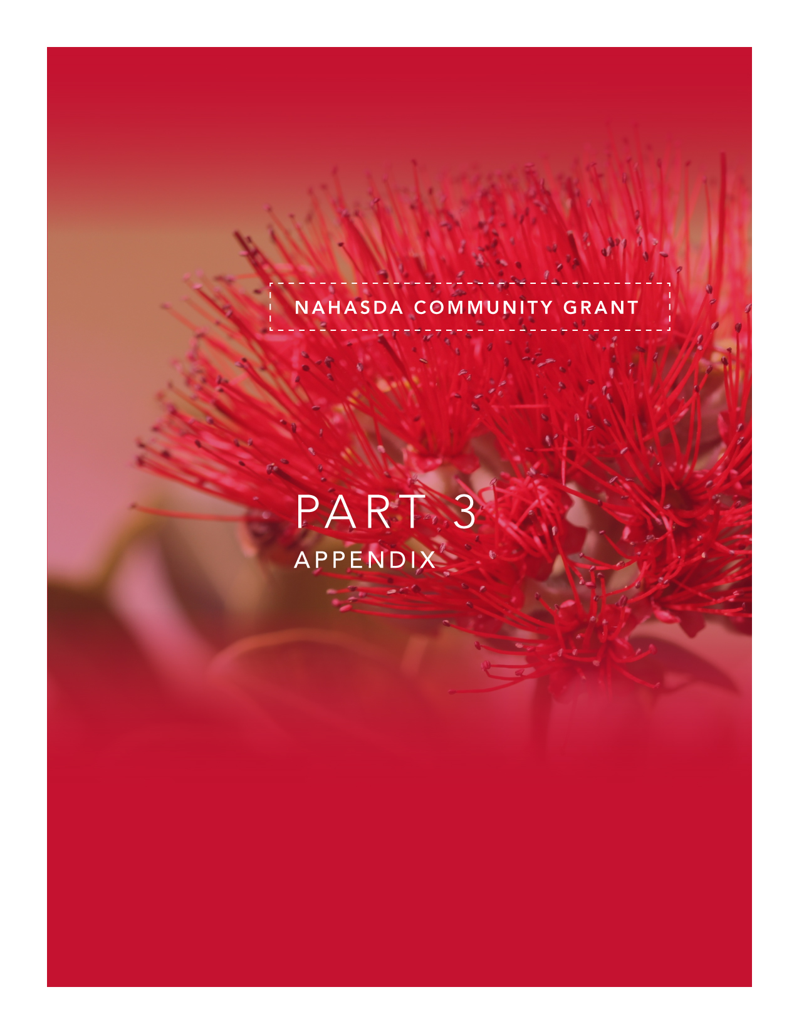

APPLICATION APPENDIX

TABLE OF CONTENTS
TITLE PAGE

APPLICATION ATTACHMENT CHECKLIST 1
NATIVE HAWAIIAN HOUSING PLAN GOALS AND OBJECTIVES 2
SAMPLE RESOLUTION 7
SAMPLE PROGRAM/PROJECT GOAL AND OBJECTIVES 9
SAMPLE WORK PLAN 10
WORK PLAN 11
SAMPLE BUDGET NARRATIVE 12
SAMPLE LINE ITEM BUDGET 13
SAMPLE ORGANIZATIONAL CHART 14
SAMPLE: PROGRAM/PROJECT ADMINISTRATION CHART 15
PROGRAM/PROJECT CONCEPT AND DEVELOPMENT 16
PROCESS FLOW CHART 17
DEFINITIONS 18
HUD INCOME LIMITS 18
HAWAII COMPLIANCE EXPRESS 19
FEDERAL REGISTER 19

APPLICATION ATTACHMENT CHECKLIST
- Submit the application and attachments in the following order.
- Separate attachments as indicated with tabbed dividers
- Label each tab as indicated.

Label Divider Tab | Place behind tab the following information:
Section A 3.2 | Copy of resolution authorizing this application.  Copy of Articles of Incorporation and By-Laws.  The Enabling Resolution or Charter, for public organizations  List of names of the Governing Body, Board Members and Corporate Officers
Section A 3.3 | 501(c)3 Status with Secretary of State Certification. (If Applicable )  Financial Statements: The most recent two (2) years of Income Statements and Balance Sheets  State of Hawaii Tax Clearance (within 6 mos. of application)
Section A 3.4 | Additional narrative if necessary  References from 3-5 funding sources  Your Agency/Organization’s organizational chart.
Section A 3.5. | Additional narrative if necessary. *
Section B 1.3 | Additional narrative if necessary.*
Section B 2.1 | Additional narrative if necessary  A map of the community if applicable.  Documentation of the targeted community’s income level
Section B 3.1 | Additional objectives if necessary. *
Section B 3.2 | A work Plan for each objective.
Section B 3.3 | Additional Contractors if necessary. *
Section B 4.1 | Additional narrative if necessary. *
Section B 4.2 | Additional contributors if necessary.  A Letter of Commitment from each contributing partner dated no earlier than one (1) month prior to this application.
Section B 5.1 | Additional narrative if necessary. *
Section B 6.1 | Additional narrative if necessary. *
Section B 6.2 | Additional budgeting information if necessary. *
Section B 7.1 | A job description for each job title listed.  A resume for each staff person assigned to the program/project.  A program/project administration chart.
Section C 1.2 | Additional narrative if necessary. *

If the narratives and tables are complete in the application, it is not necessary to make tabs solely for these items.

2011 NATIVE HAWAIIAN HOUSING PLAN GOALS AND OBJECTIVES
The Department of Housing and Urban Development (HUD) requires DHHL to develop a one (1) year and a five (5) year Native Hawaiian Housing Plan (NHHP) for each appropriation. The following outlines DHHL’s primary goals for this program year for NAHASDA funding to best serve its targeted communities.

Goal No. 1: Increase the affordable housing inventory on Hawaiian home lands to meet the increasing or unmet demand for housing by eligible native Hawaiian households.

Objective 1A: Increase the supply of affordable housing units through on-site and off-site development, to include but not limited to infrastructure, streets, utilities, and engineering, for single-family housing.

Tasks and Activities: Provide funding for on-site or off-site development improvements for at least one single-family residential subdivision on the island of O'ahu to serve at least 20 eligible native Hawaiian households and one on an outer island to serve at least 10 eligible native Hawaiian households.

Objective 1B: Increase the supply of affordable housing units through self-help (sweat equity) projects.

Tasks and Activities: Provide funding for technical assistance for at least one affordable housing project that utilizes the self-help construction method to assist at least 20 eligible native Hawaiian households achieve homeownership.

Objective 1C: Reduce the price of housing by providing direct assistance to eligible native Hawaiian homebuyers through downpayment assistance and/or principal reduction subsidies, low/no interest rate loans, matching funds for Individual Development Accounts (IDAs), or other means/methods that become available.

Tasks and Activities:
- Provide funding for subsidies, such as downpayment assistance/principal reduction or matching funds for Individual Development Accounts (IDA), which may be recaptured during the useful life period, for at least 10 eligible native Hawaiian households.

- Provide low-interest or no-interest loans to at least 20 eligible native Hawaiian households.

Objective 1D: Increase the supply of affordable housing units by providing funding for house construction for single-family housing which may include solar water heating, photovoltaic panels, and/or other energy efficient features.

Tasks and Activities: Provide funding for at least one single-family residential subdivision on the island of O'ahu to serve at 20 eligible families and one single family residential subdivision on the neighbor islands to serve 10 families.

Objective 1E: Assess the demand for alternative housing options (i.e. rental housing, assisted living, or other housing options) on Hawaiian Home Lands and implement programs as applicable.

Tasks and Activities:
- Complete a data assessment/analysis of the demand for rental housing on HHL by current DHHL applicants.

- Explore the feasibility of implementing a rental program for DHHL applicants on HHL given the Hawaiian Homes Commission Act requirements vs. the feasibility of assisting partners in developing rental properties on HHL.

- As applicable, establish Administrative Rules and Operational Policies should it be deemed feasible and necessary to implement a rental program for DHHL applicants on HHL.

Objective 1F: Increase the supply of affordable housing inventory by subdividing lots or relocating homes, as practicable.

Tasks and Activities: .
- Subdivide lots returned to DHHL’s inventory, as practicable, and re-award to eligible native Hawaiian households.

- Relocate existing homes on lots returned to DHHL to facilitate subdivision of said lot, as practicable.

Objective 1G: Increase the supply of affordable housing units through acquisition of land and/or housing units to be included in DHHL’s inventory of affordable housing for eligible native Hawaiian families.

Objective 1H: Capitalize a revolving loan fund that will provide financing to assist native Hawaiian NAHASDA eligible families with affordable mortgage financing options to achieve and sustain homeownership on Hawaiian Home Lands.

Goal No. 2: Reduce the number of homes, occupied by eligible native Hawaiian households, that are in need of repair or replacement to relieve substandard living conditions, that are in need of renovation to relieve overcrowding, or to provide energy efficient renovation/upgrades.

Objective: Increase the number of programs and/or partnerships that provide assistance to eligible native Hawaiian households in the repair or replacement or their homes or to renovate their homes as a means to relieve over crowding, or to provide energy efficient renovations/upgrades.

Tasks and Activities:
- Provide low-interest or no-interest loans and/or grants to at least 10 eligible native Hawaiian households to repair/rehabilitate existing housing units to address substandard living conditions, to renovate existing housing units to address over crowding, or to provide energy efficient renovations/upgrades..

- Initiate new partnerships and/or encourage the development of programs that target areas or needs that are not currently being served by existing City and County, or other, partnerships/programs.

Goal No. 3: Increase alternative energy resources and/or programs that will benefit eligible native Hawaiian households.

Objective 3A: Provide funding to eligible entities to implement alternative energy resource programs for eligible native Hawaiian households as a means to reduce housing costs and in alignment with the DHHL energy policy.

Tasks and Activities:
Provide funds, to include direct loans and/or grants to eligible beneficiaries, and/or implement a program, to install energy efficient devices to include, solar water heating, photovoltaic panels, and/or other energy efficient features for eligible native Hawaiian households.

Goal No. 4: Increase community access to NHHBG resources to address public safety needs, organizational needs, community policing needs, or eligible “model” activity needs.

Objective: Support communities on Hawaiian Home Lands to assess the viability of developing and implementing eligible NHHBG programs and activities that will benefit their communities such as, but not limited to, safety enhancements, organizational support, community policing, or eligible “model” activities.

Tasks and Activities:
- Provide resources for homestead communities to determine the number/percentage of their residents that are NHHBG eligible (at or below 80% AMI).

- Assist homestead communities in addressing community safety needs, as warranted by the particular community, and in alignment with allowable activities for the NHHBG.
- Assist homestead communities with community policing activities, as warranted by the particular community, and in alignment with allowable activities for the NHHBG.

- Promote partnerships with existing providers and the police departments within each county to address public safety needs.

- Assist homestead communities and affiliated organizations by working in coordination with the community/organization and HUD in determining what types of “model activities” DHHL may consider for NHHBG funding that include elements such as social, educational, cultural, recreational, or medical related activities for a more holistic approach to housing than just providing shelter.
.
Goal No. 5: Increase access to educational or training programs that assist native Hawaiian families.

Objective 5A: Develop, maintain, or improve educational and/or training programs to address financial, home repair, home maintenance, or other needs for eligible native Hawaiian households.

Tasks and Activities:
- Continue to work with and/or fund eligible entities, including DHHL’s Home Ownership Assistance Program (HOAP), to provide financial literacy education and counseling, home buyer education, and foreclosure prevention to eligible native Hawaiian households.

- Continue to work with and/or fund eligible entities to provide home maintenance and/or self-help home repair training programs to eligible native Hawaiian households.

- Provide support or funding for other eligible educational or training programs to eligible native Hawaiian households.

Goal No. 6: Increase administrative capacity of DHHL to implement and monitor NHHBG programs.

Objective 6A: Comply with both state and federal requirements in the administration of the NHHBG and ensure adequate organizational capabilities to manage the various NHHBG programs, properties, and assets on Hawaiian home lands.

Tasks and Activities:
- Ensure that NHHBG programs are adequately staffed.

- Work with ONAP staff to ensure appropriate training for DHHL staff and sub-recipients for the administration of NHHBG programs.

Objective 6B: Establish collaborative partnerships to address affordable housing needs.

Tasks and Activities:
- Conduct community outreach and education, as needed, to address community interest in NAHASDA, the NHHP, and the DHHL’s NAHASDA Community Grant Program.

- Engage local lenders to utilize the 184A guaranteed loan as another lending product.

SAMPLE RESOLUTION

THE GOVERNING BOARD OF ___________________________

HEREBY AUTHORIZES THE SUBMITTAL OF AN APPLICATION, THE INCURRING OF AN OBLIGATION, THE EXECUTION OF A SUBRECIPIENT AGREEMENT AND ANY AMENDMENTS THERETO, AND ANY OTHER DOCUMENTS NECESSARY TO SECURE A NAHASDA COMMUNITY GRANT FROM THE DEPARTMENT OF HAWAIIAN HOME LANDS.

WHEREAS

A. (name of applicant organization) (hereinafter referred to as “Corporation”) is a corporate entity established under the laws of XXX and empowered to enter into an obligation to receive NHHBG funds.

B. The Department of Hawaiian Homelands (hereinafter referred to as the “DHHL”) is authorized to enter into Subrecipient Agreements, as applicable, for the disbursement of NHHBG funds.

C. The Corporation wishes to enter into Subrecipient Agreement with the DHHL for technical assistance to assist with self-help housing activities.

IT IS NOW RESOLVED THAT:

1. The Corporation may submit to the DHHL a NAHASDA Community Grant Application.
2. If the application is approved, the Corporation is hereby authorized to incur an obligation in any amount not exceeding the amount approved by the DHHL and to enter into a Subrecipient Agreement with the DHHL for the purposes set forth in the application and approved by the DHHL. It also may execute security and other instruments necessary or required by the DHHL to govern and secure the obligation.
3. The Corporation is further authorized to request amendments, and to execute any and all documents required by the DHHL to govern and secure these amendments.

4. The Corporation authorizes (name and title(s) of officer(s) authorized) to execute in the name of the Corporation, the application and the agreement, and other instruments necessary or required by the State of Hawaii for the making and securing of the Subrecipient Agreement, and any amendments thereto.

PASSED AND ADOPTED THIS DAY OF , 20 ,

BY THE FOLLOWING VOTE:

AYES: NAYS: ABSTAIN: ABSENT:

CERTIFICATION:

The undersigned Secretary of the Corporation here before named does hereby attest and certify that the foregoing is a true and full copy of a resolution of the Board of Directors adopted at a duly convened meeting on the date above-mentioned, which has not been altered, amended, or repealed.

Secretary Date

NOTES:

1. This is intended to be a model for resolutions authorizing grant applications. Applicants may use their own format if it contains substantially all the authorizations in the model.

2. This model uses language appropriate to a nonprofit corporation of cooperative. A government agency may want to substitute more appropriate terminology for terms such as "Governing Board" and "Corporation".

- The person attesting to the vote and certifying the resolution may not be a person authorized by the resolution to execute documents.

SAMPLE PROGRAM/PROJECT GOAL AND OBJECTIVES
PROJECT NAME: DHHL Accessibility Project

PROJECT GOAL: To have all public access buildings on Hawaiian Home Lands on the Big Island physically accessible for disabled persons by the end of a twelve-month period.

 | OBJECTIVE
1 | A thorough and accurate assessment report of the current accessibility status of all relevant buildings, including an inventory of necessary improvements to be accessible for disabled persons to be completed by the end of the second month
2 | A database of diversified trades persons appropriately skilled and agreeable to providing a minimum of 5 days of volunteer work over a twelve-month period to be completed by the end of the third month
3 | A project management plan for completing all necessary improvements including timeframes, critical paths, assigned construction co-coordinators and resources, to be completed by the end of the fifth month.
4
5

SAMPLE WORK PLAN
WORK PLAN

Program/  Project Name: | DHHL Accessibility Project
Program/  Project Year: | Year 1.
Program/  Project Goal: | To have all public access buildings on Hawaiian Home Lands on the Big Island physically accessible for disabled persons by the end of a twelve-month period.
Objective #1: | A thorough and accurate assessment report of the current accessibility status of all relevant buildings, including an inventory of necessary improvements to be accessible for disabled persons to be completed by the end of the second month.
Outcome: An assessment report identifying the existing inventory of necessary improvements and the status of each.
Activities |  | Position Responsible | Time Period |  | Non-Salary Personnel Hours
 |  | Position Responsible | Begin Month | End Month | Non-Salary Personnel Hours
Hire a project coordinator. |  | Agency Admin. /Board | 1 | 1 | 8 in-kind
Develop assessment tool. |  | Project Coordinator | 1 | 2
Data mine existing secondary data sources. |  | Project Coordinator | 1 | 2
Test assessment tool. |  | Project Coordinator | 1 | 2
Implement assessment. |  | Project Director | 1 | 2
Draft assessment report for board review and approval. |  | Project Director | 1 | 2
Criteria for Evaluating Outcomes: Assessment report will be reviewed and approved by the Board in preparation for Objective #2.

WORK PLAN

Program/Project Name:
Program/Project Year:
Program/Project Goal:
Objective #
Outcome:
Activities | Position Responsible | Time Period |  | Non-Salary Personnel Hours
Activities | Position Responsible | Begin Month | End Month | Non-Salary Personnel Hours
1.
2.
3.
4.
5.
6.
7.
8.
9.
10.
11.
12.
13.
14.
15.

SAMPLE BUDGET NARRATIVE
PERSONNEL
This project will require 1.5 FTE to complete. They are as follows:
- Executive Director will dedicate 10% of his/her position to supervising the project. The Executive Director salary is an in-kind contribution to the project.
- Project Coordinator will dedicate 100% of his/her time to administering the project. NHHG funds are requested for the Project Coordinator position at $40,000 annually plus 30% fringe of $12,000 ($40,000 x .3).
- Office Manager will dedicate an estimated 50% of his/her time to the project. NHHBG funds are requested for the Project Coordinator position at $15,000 ($30,000 x .5) annually plus 50% of fringe estimated at $4,500 ($30,000 x .3 = $9,000 x .5).

EMPLOYEE BENEFITS
Benefits are calculated at 30% of wage. The Executive Director benefit costs are an in-kind contribution to the project. The Project Coordinator and Office Manager benefit costs are requested from DHHL.

NON-PERSONNEL
It is estimated that this project will constitute 50% of our total work for the next twelve (12) months and non-personnel costs are budgeted at 50% of prior year’s costs except for space rental which will be a donation in-kind.

Space Rent – In Kind donation, the organization will donate 2 offices (1600sq ft) for twelve (12) months.
Telephone - The estimated cost of 2 telephone lines plus service, local and long distance for twelve (12) months.
Equipment – leasing of copy machine for 12 months.
Office Supplies - Costs include printing, postage, and other supplies directly needed for the project.

SAMPLE LINE ITEM BUDGET
 |  |  | Grant Funds |  | Other Funds |  | In Kind |  | Total
 |  | PERSONNEL SERVICES
 |  | 1. Salaries |  | 55,000 |  | 15,000 |  |  | 70,000
 |  | 2. Employee benefits |  | 16,500 |  | 4,500 |  |  | 21,000
 |  | SUB-TOTAL PERSONNEL |  | 71,500 |  | 19,500 |  |  | 91,000
 |  | NON-PERSONNEL
 |  | 3. Space rent |  |  |  |  |  | 6,000 | 6,000
 |  | 4. Utilities |  | 1,200 |  | 1,200 |  |  | 2,400
 |  | 5. Telephone |  | 1,500 |  | 1,500 |  |  | 3,000
 |  | 6. Equipment (leasing) |  | 300 |  | 300 |  |  | 600
 |  | 7. Office materials |  | 900 |  | 900 |  |  | 1,800
 |  | 8. Contract and Professional Services
 |  | 9. Other costs (detail):
 |  | a.
 |  | b.
 |  | c.
 |  | SUB-TOTAL NON-PERSONNEL |  | 3,900 |  | 3,900 |  | 6,000 | 13,800
 |  | TOTAL BUDGET |  | 75,400 |  | 23,400 |  | 6,000 | 104,800

SAMPLE ORGANIZATIONAL CHART

Executive Director

Director of Community Programming

Director of Grants/Legislative Liaison

Trainer

NAHASDA Coordinator

Assistant
Project Director
Project Director

SAMPLE: PROGRAM/PROJECT ADMINISTRATION CHART

NAHASDA COORDINATOR
Project Director
Volunteer Coordinator
Community Service Person

PROGRAM/PROJECT CONCEPT AND DEVELOPMENT

Targeted Community
Proposed Project
Project
Project
GOAL
Objective
Objective
Objective
Activity
Activity
Activity
Activity
Activity
Activity
Activity
Activity
Challenges, Issues & Needs

PROCESS FLOW CHART

no

yes

Pick up NAHASDA Community Application and Process
Complete Application

Develop Program/Project Goal, Objectives & Work Plans
Submit to DHHL by deadline
DHHL Reviews and makes a Determination
DHHL Approved
Deferred for Additional Information

Denied with Comment
Complete requested information
Receive Funding
Does the Program/Project have a Goal Objectives & Work Plans?
DHHL notifies of approval
Sub-Recipient submits Quarterly Reports to DHHL

DEFINITIONS

COST/SHARE | Total project costs shared between federal and non-federal funding sources.
MATCHING FUNDS | Non-federal portions commonly referred to as matching funds.
SELF HELP
CFR | The Code of Federal Regulations
KUPUNA | Grandparent, ancestor, relative or close friend of grandparents generation
GOALS | A general statement that represents a desired outcome such as “to reduce the unemployment rate.”
OBJECTIVES | A specific statement that represents a desired Outcome. A good objective should answer questions such as WHO, WHAT, WHEN, & HOW. The objective must also be measurable, attainable and clearly stated.
OUTCOMES | Expected results or impacts your organization will gain from successful implementation of your project.
ACTIVITIES | A specific effort that your plan to implement to meet your objective.

HUD INCOME LIMITS

2012 NAHASDA Income Limits 80% AMI
Effective: December 1, 2011
 | 1 Person | 2 Person | 3 Person | 4 Person | 5 Person | 6 Person | 7 Person | 8 Person
Honolulu County | $57,700 | $65,950 | $74,200 | $82,400 | $89,000 | $95,600 | $102,200 | $108,800
Hawaii County | $44,450 | $50,800 | $57,150 | $63,500 | $68,600 | $73,700 | $78,750 | $83,850
Kalawao County | $44,450 | $50,800 | $57,150 | $63,500 | $68,600 | $73,700 | $78,750 | $83,850
Kauai County | $46,150 | $52,750 | $59,350 | $65,900 | $71,200 | $76,450 | $81,750 | $87,000
Maui County | $50,050 | $57,200 | $64,350 | $71,500 | $77,250 | $82,950 | $88,700 | $94,400

HAWAII COMPLIANCE EXPRESS (HCE)

Your organization is required to include a Certificate of Vendor Compliance. As of July 1, 2011 State and County procurement personnel are required to utilize the Hawaii Compliance Express (HCE) to obtain proof of compliance prior to award. Vendors, contractors and service providers who need to register in HCE should follow instructions of FAQ No. 3, “How do I register my business in the HCE?” located at the website. The link to HCE is attached for your convenience. https://vendors.ehawaii.gov/hce/splash/welcome.html Your organization will need to register on Hawaii Compliance Express. You will need the following items for your registration online; Federal and State ID numbers, and a credit card for the registration fee to register on the site. The annual registration fee is $12.00. Activation of your organizations information on the HCE site will take approximately 5-10 days from registration date.

FEDERAL REGISTER
The Code of Federal Regulations (CFR) is a set of publications that establish policies for everything from Agriculture to Wildlife and Fisheries. Defined by the Office of the Federal Register, the Code of Federal Regulations is "a codification of the general and permanent rules published in the Federal Register by the Executive Departments and agencies of the Federal Government. As such, these regulations are the definitive source of information for this program.

Housing Assistance for Native Hawaiians: Native Hawaiian Housing Block Grant Program and Loan Guarantees for Native Hawaiian Housing; Interim Rule (June 13, 2002) and Final Rule (November 28, 2003) is in Federal Register (24 CFR Parts 1006 and 1007). You may view these Rules on the DHHL Website at http://hawaii.gov/dhhl/nahasda.

An “eligible native Hawaiian household” is 1) a household that is eligible to reside on Hawaiian home lands and 2) has household income (all working adults) at or below 80% of Area Median Income. All activities in this plan must serve “eligible native Hawaiian households”.
An “eligible native Hawaiian household” is 1) a household that is eligible to reside on Hawaiian home lands and 2) has household income (all working adults) at or below 80% of Area Median Income. All activities in this plan must serve “eligible native Hawaiian households”.

